Chapter 9 Bats, balls and boots — collisions in sport
Short investigation 9.1: Conservation of linear momentum
Name:
Aim
To investigate the transfer of momentum in a linear system
Materials
2 dynamics trolleys with collision clips, 2 kg weight, scales, wooden plank or ramp, 3 bricks, data logger and motion sensors or ticker timer equipment
Method
- Set up the equipment as shown in the figure below.
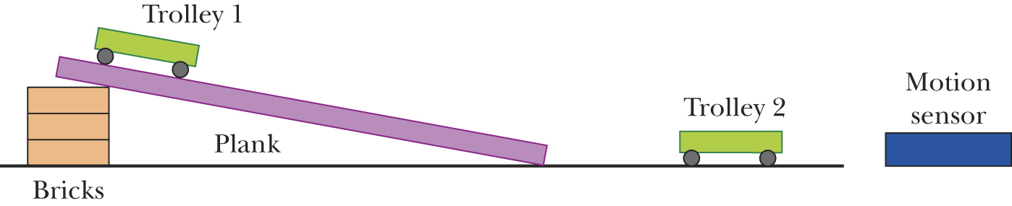
- Attach a motion sensor or ticker tape to the trolley at the top of the slope. Align a second motion sensor with the trolley at rest on the flat surface (or attach ticker tape to it).
- Ensure the slope is aligned with the trolley at rest on the flat surface so the trolleys will collide.
- Turn on the sensors or ticker timers, and release the trolley on the slope. If the collision clips do not activate, repeat the investigation.
- Unhook the trolleys and measure their mass. Enter these masses in table 9.1A.
- Using the data from the data logger or ticker tapes, determine the speed of each of the trolleys just before and just after collision. Enter these values in table 9.1A.
Results
Table 9.1A
Trolley | Mass (kg) | u (m s^{–1}) | v (m s^{–1})
1
2 |  | 0
1 + 2

Analysing the results
- Using the data in table 9.1A, calculate the following:
  - momentum of trolley 1 before the collision
  - momentum of trolley 2 before the collision
  - momentum of the combined trolleys after the collision.
- Using your answers to question 1, determine:
  - the total momentum of the system before the collision
  - the total momentum of the system after the collision.
- In theory, your answers to 2(a) and 2(b) should be the same. Explain why they are not.
Conclusion
State the relationship between the momentum of the two trolleys before collision and their combined momentum after the collision.
Notes:

